Year 11 ATAR Modern History - PRACTICE SOURCE ANALYSIS

Use the four sources provided to answer the following questions.

(a) Explain the historical context of Source 1. Include the relevant events, people and ideas depicted or represented in the source. (4 marks)

(b) Compare and contrast the purpose of Sources 1 and 2. (5 marks)

(c) Explain the message of Source 3. (3 marks)

(d) Identify how, and discuss why, Sources 3 and 4 are contestable. (6 marks)

(e) Using your knowledge of the whole period of study, evaluate the importance of the themes, ideas and/or events represented in the four sources. (7 marks)

End of source analysis
Source Booklet

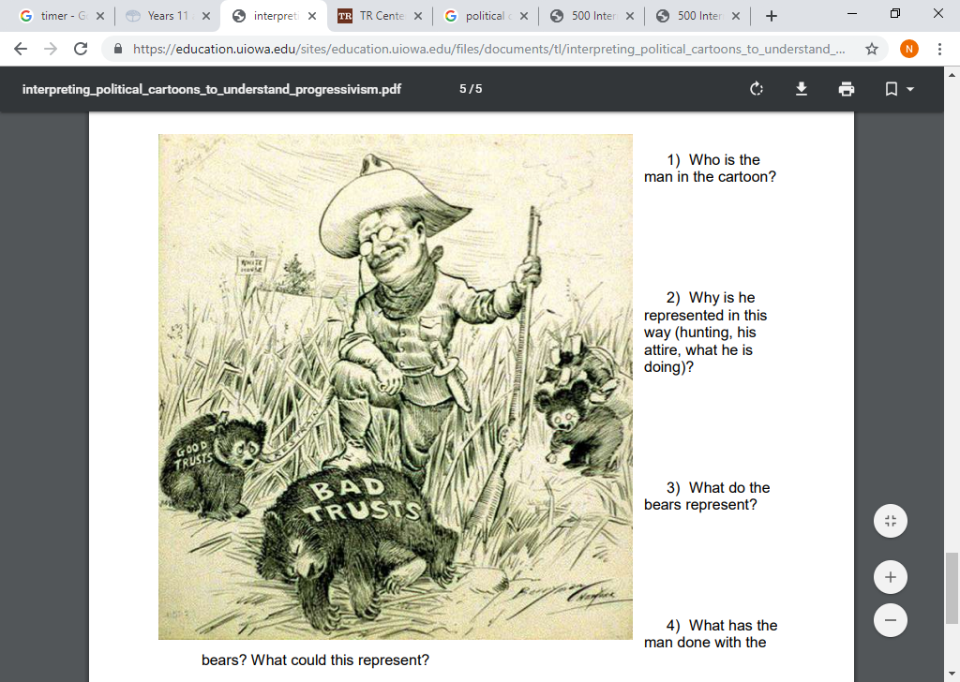
Source 1: A political cartoon published in 1907.

Source 2: An excerpt from a speech given by Theodore Roosevelt during the 1912 Presidential election, called The Liberty of the People speech.

“We propose to extend governmental power in order to secure the liberty of the wage workers, of the men and women who toil in industry, to save the liberty of the oppressed from the oppressor. Mr. Wilson stands for the liberty of the oppressor to oppress. We stand for the limitation of his liberty not to oppress those who are weaker than himself.”

Source 3: An excerpt from an article titled, Teddy Roosevelt Is No Model for a President, written by historian David Boaz, 2011.

“Theodore Roosevelt was almost entirely focused on politics – personalities, speeches, publicity and so on. He seemed to be concerned about an economic issue only when it became a big problem, particularly if it was big enough to affect the next election. There wasn’t much evidence of long-term thinking beyond the next election. Certainly there was no evident awareness of unintended consequences.”

Source 4: An excerpt from an article titled, Theodore Roosevelt: Impact and Legacy, written by historian Sidney Milkis, 2019.

“Theodore Roosevelt is widely regarded as the first modern President of the United States. The stature and influence that the office has today began to develop with TR. Throughout the second half of the 1800s, Congress had been the most powerful branch of government. And although the presidency began to amass more power during the 1880s, Roosevelt completed the transition to a strong, effective executive. He made the President, rather than the political parties or Congress, the center of American politics.”

